**GREENARY FLOWER SHOPPE**

**CONTENTS**

1. **ABSTRACT**
2. **INTRODUCTION**
3. **SYSTEM ANALYSIS**
   1. 3.1 EXISTING SYSTEM
   2. 3.2PROPOSED SYSTEM
   3. 3.3 REQUIREMENT ANALYSIS
   4. 3.4 REQUIREMENT SPECIFICATIONS
   5. 3.5 FEASIBILITY STUDY

**4. SYSTEM DESIGN**

* 1. PROJECT MODULES
  2. DATA DICTIONARY
  3. DATA FLOW DIAGRAMS
  4. E-R DIAGRAMS

**5. LANGUAGE SPECIFICATION**

1. **CODING**

**7 SCREENS**

**8 . SYSTEM TESTING**

**9 .CONCLUSION**

**10.BIBLIOGRAPH**

1. **ABSTRACT**

**The Greenery flower Shoppe is the family owned and easy operated finest floral online gift Shoppe. The Greenery proudly serves the Toronto area**. We are family owned and operated. We are committed to offering only the finest floral arrangements and gifts, backed by service that is friendly and prompt. Because all of our customers are important, our professional staff is dedicated to making your experience a pleasant one. That is why we always go the extra mile to make your floral gift perfect.

For fresh, high-quality flowers in Toronto, you can count on The Greenery. Our professional staff of florists in Toronto will work with you to create beautiful, unique gifts for your special occasions. Not only do we provide flower delivery in Toronto, we can deliver nationwide as well through our trusted network of florists. We even offer same day flower delivery at no extra cost for those last-minute gifts!  
We all know to send flowers on Valentine�s Day, Mother�s Day, birthdays and anniversaries, but why not make today extra special? The Greenery can help you send the perfect gift to show your loved ones how much you care. We�re proud to be one of the leading florists in Toronto and have a wonderful selection of gifts and flower arrangements for you to choose from. Our floral designers use only superior flowers in our arrangements

**2.INTRODUCTION**

**The Greenery proudly serves the Toronto area**. We are family owned and operated. We are committed to offering only the finest floral arrangements and gifts, backed by service that is friendly and prompt. Because all of our customers are important, our professional staff is dedicated to making your experience a pleasant one. That is why we always go the extra mile to make your floral gift perfect.

Our shop is open from 10:00 a.m. to 7:00 p.m., Monday through Friday and from 10:00 a.m. to 6:00 p.m. on Saturday. We are closed on Sundays. To help assure on-time delivery during the busy holiday season, place your order at least 1 day prior to the following major holidays: Thanksgiving Day, Christmas Day, New Year's Day, Valentine's Day, Easter, Administrative Professionals Week, Mother's Day, Memorial Day, Father's Day, Independence Day and Labor Day. Our shop will always be closed on the following holidays: Family Day, Canada Day, Civic Holiday, Thanksgiving Day, Christmas Day, Boxing Day, New Year's Day, Easter, and Father's Day.

A local delivery fee of $9.95 will be added to each order, for each address. (For deliveries outside our local delivery area, this fee may vary.) U.S. orders must be received before 12:00 noon in the recipient's time zone to assure same-day delivery. Orders received after that time will be delivered the following day. We will do our best to accommodate deliveries at specific times of day, but we cannot guarantee it.

We are unable to make deliveries on Sundays. Deliveries requested on this day will be delivered the following business day. Delivery of orders to rural route addresses or cemeteries cannot be guaranteed. We will be happy to accept your international orders if you call our shop directly. We are unable to accept international orders over the Internet.

We specialize in the following services:

* Large inventory of fresh flowers
* Tropicals
* Plants
* European/dish gardens
* Contemporary and traditional arrangements
* High-style floral arrangements
* Silk arrangements
* Dried floral arrangements
* Weddings
* Funeral designs
* Extensive gift line
* Gourmet and fruit baskets
* Gift baskets
* Greeting cards
* Candles

**Information We Collect**  
If you open an account on our site or make a purchase, we need your contact information including your name, e-mail address and mailing address to complete your transaction.   
When you visit our website, we also collect some basic information that does not identify individual users. We use this information to determine our users demographics and interests, so that we can better understand and serve our users.

**"Cookies"**  
Cookies are small files which store certain information about your activity on the website and are stored on your computer’s hard drive. Our cookies do not contain any personally identifying information. We use cookies to let us know that you are a prior customer, so that you don’t have to reenter information you gave us on your prior visits. Most web browsers automatically accept cookies, but most allow you to instruct your browser to prevent the use of cookies. However, if you disable cookies, you will not be able to use certain features of this website.

**Our Use and Disclosure of Your Information**  
When opening an account or making a purchase, you have an opportunity to opt-in or opt-out from receiving emails from us. If you opt-in to receive information from us, we may use your purchase history, contact information and other registration information to provide you with more relevant information and email content. We may send emails to our users regarding changes in our services or other information we believe will be of interest to our users. If you prefer not to receive these emails, you can send us an email with the subject line no emails or reply to our email with the subject line no emails.   
If you send us personal correspondence, such as emails or letters, or if other users or third parties send us correspondence about your activities on our site, we may collect such information. We may use that information and other information that we obtain from your use of our site to resolve disputes, troubleshoot problems and enforce our agreement for Terms of Use.   
We may share aggregate statistics about our sales, traffic patterns and related site information with other businesses, but these statistics will include no personally identifying information.   
  
We may share your information with Teleflora and other reputable vendors for the purpose of sending out special offers via email and/ or in connection with the services provided by our site such as the delivery of flowers. Your information will not be shared for any other purpose and will be kept secured.   
We cannot ensure that all of your private communications and other personally identifiable information will never be disclosed in ways not otherwise described in this Privacy Statement. For example, we may be required to disclose information to the government or third parties under certain circumstances, or third parties may unlawfully intercept or access transmissions or private communications. We can (and you authorize us to) disclose any information about you to law enforcement or other government officials as we, in our sole discretion, believe necessary or appropriate in connection with an investigation of fraud, intellectual property infringements, or other activity that may be illegal or may expose us to legal liability.   
**Security**  
This site has security measures in place to protect the loss, misuse and alteration of the information under our control.   
All user credit card information is securely communicated using secure socket layer (SSL) software, which is the industry standard and among the best software available for secure commerce transactions.   
All user information stored on our server is stored in an encrypted format. Notwithstanding these efforts, we caution you that perfect security does not exist on the Internet.   
**Linked Sites**  
If this site contains any links to other websites, we are not responsible for the privacy practices or the content of such websites.  
  
**Changes to Privacy Statement; Consent**  
We may update this Privacy Statement from time to time. You should check this page periodically for changes. By using our site, you consent to the collection and use of your information by us as described in this Privacy Statement.  
**Questions and Comments**  
We welcome your questions and comments about this Privacy Statement.

1. **SYSTEM ANALYSIS**

System Analysis is first stage according to System Development Life Cycle model. This System Analysis is a process that starts with the analyst.

Analysis is a detailed study of the various operations performed by a system and their relationships within and outside of the system. One aspect of analysis is defining the boundaries of the system and determining whether or not a candidate system should consider other related systems. During analysis, data are collected on the available files, decision points, and transactions handled by the present system.

Logical system models and tools that are used in analysis. Training, experience, and common sense are required for collection of the information needed to do the analysis.

**Requirements Analysis**

The requirement phase basically consists of three activities:

1. Requirement Analysis
2. Requirement Specification
3. Requirement Validation

**Requirement Analysis:**

Requirement Analysis is a software engineering task that bridges the gap between system level software allocation and software design. It provides the system engineer to specify software function and performance indicate software’s interface with the other system elements and establish constraints that software must meet.

The basic aim of this stage is to obtain a clear picture of the needs and requirements of the end-user and also the organization. Analysis involves interaction between the clients and the analysis. Usually analysts research a problem by asking questions and reading existing documents. The analysts have to uncover the real needs of the user even if they don’t know them clearly. During analysis it is essential that a complete and consistent set of specifications emerge for the system. Here it is essential to resolve the contradictions that could emerge from information got from various parties. This is essential to ensure that the final specifications are consistent.

It may be divided into 5 areas of effort.

1. Problem recognition
2. Evaluation and synthesis
3. Modeling
4. Specification
5. Review

Each Requirement analysis method has a unique point of view. However all analysis methods are related by a set of operational principles. They are

* The information domain of the problem must be represented and understood.
* The functions that the software is to perform must be defined.
* The behavior of the software as a consequence of external events must be defined.
* The models that depict information function and behavior must be partitioned in a hierarchical or layered fashion.
* The analysis process must move from essential information to implementation detail.

**Requirement Analysis in this Project**

The main aim in this stage is to assess what kind of a system would be suitable for a problem and how to build it. The requirements of this system can be defined by going through the existing system and its problems. They discussing (speak) about the new system to be built and their expectations from it. The steps involved would be

**Problem Recognition:**

The main problem here is the more time is taken to manage the different documents. This has to be eliminated. A comprehensive solution has to be developed which will facilitate to fulfill the requirements faster and more efficient way.

**Evaluation and Synthesis:**

The system has to be designed only after complete evaluation of the existing one, upon which we can see that a lot depends on the medium of communication. The proposed system is used to maintain all the documents details in the database category wise, to avail them to all the employees. So this has to be used such that there is no waste of time.

**Specification:**

The specifications from the user, here maintaining all documents of the knowledge manually lead to unnecessary publishing. The appearance of forms, and their field names, the different screens he desired, the stages of this database etc., were all given. The system has been built following all the specifications.

**SYSTEM ANALYSIS:**

**3.1EXISTING SYSTEM**

The existing system is a manual presentation. If you want to send any bouquet to particular person it takes lot of time because of we have to go for flower shop and select the flowers and pay the money. This entire process is going to take a lot of time and manpower.

To reduce human effort we need a computerized system it can access from any where in the universe. Existing system creates a lot of confusion in delivering the flowers or bouquet.

**3.2PROPOSED SYSTEM**

If you send us personal correspondence, such as emails or letters, or if other users or third parties send us correspondence about your activities on our site, we may collect such information. We may use that information and other information that we obtain from your use of our site to resolve disputes, troubleshoot problems and enforce our agreement for Terms of Use.

We may share aggregate statistics about our sales, traffic patterns and related site information with other businesses, but these statistics will include no personally identifying information.   
We may share your information with Teleflora and other reputable vendors for the purpose of sending out special offers via email and/ or in connection with the services provided by our site such as the delivery of flowers. Your information will not be shared for any other purpose and will be kept secured.   
1. It is web based application it can access any where .

2. It takes less human effort than the existing manual system.

3. we can directly select any type of flowers or bouquet.

4. It is easy process to send any person from any where.

5. It is easy to pay the bills like e-commerce system.

**SOFTWARE REQUIREMENTS**:

Operating System : Windows

Technology : Java/j2ee (JDBC, Servlets, JSP)

Web Technologies : Html, JavaScript, CSS

Web Server : Tomcat

Database : MySql (xamp)

Software’s : J2SDK1.5, Tomcat 5.5.

**HARDWARE REQUIREMENTS:**

Hardware : Pentium based systems with a minimum of P4

RAM : 256MB (minimum)

**3.5 FEASIBILITY STUDY**

**Economic Feasibility**

Economic feasibility attempts 2 weigh the costs of developing and implementing a new system, against the benefits that would accrue from having the new system in place. This feasibility study gives the top management the economic justification for the new system.

A simple economic analysis which gives the actual comparison of costs and benefits are much more meaningful in this case. In addition, this proves to be a useful point of reference to compare actual costs as the project progresses. There could be various types of intangible benefits on account of automation. These could include increased customer satisfaction, improvement in product quality better decision making timeliness of information, expediting activities, improved accuracy of operations, better documentation and record keeping, faster retrieval of information, better employee morale.

**Operational Feasibility**

Proposed project is beneficial only if it can be turned into information systems that will meet the organizations operating requirements. Simply stated, this test of feasibility asks if the system will work when it is developed and installed. Are there major barriers to Implementation? Here are questions that will help test the operational feasibility of a project:

Is there sufficient support for the project from management from users? If the current system is well liked and used to the extent that persons will not be able to see reasons for change, there may be resistance.

Are the current business methods acceptable to the user? If they are not, Users may welcome a change that will bring about a more operational and useful systems.

Since the proposed system was to help reduce the hardships encountered. In the existing manual system, the new system was considered to be operational feasible.

**Technical Feasibility**

Evaluating the technical feasibility is the trickiest part of a feasibility study. This is because, .at this point in time, not too many detailed design of the system, making it difficult to access issues like performance, costs on (on account of the kind of technology to be deployed) etc. A number of issues have to be considered while doing a technical analysis.

Understand the different technologies involved in the proposed system before commencing the project we have to be very clear about what are the technologies that are to be required for the development of the new system.

**4.SYSTEM DESIGN**

* 1. **PROJECT MODULES**

**MODULES:**

1. Administrative module

2. Category module

3. Customer module

4. Reports module

**Modules description:**

1. **Administrative module:**

Administrator maintain the admin module this administrator is unique. The administrator to add the products and categories of the greenery flower shopee. Each and every minute to add the flowers, bouquet and different flowers are introduced in the market each and every one add the greenery shopee. And the administrator to update the flowers each and every minute. Customers to purchase the any flower the administrator to gather the information of that particular flowers and customer’s address after that the administrator to send the flowers of that particular address. The administrator is update the site every one.

1. **Category Module :**

The administrator to add the categories, update the category and delete the category and that particular categories to add the products. Administrator adds the categories the categories and products are updated in the customer module. The categories are added in the special occasions and special bouquet.

1. **Customer module:**

The customer to purchase the any flowers of different functions or occasions first of all select the bouquet or flowers and details about of that particular flowers. And find out the cost of that particular flower and pay the money is e-commerce procedure. First time open the customer is our site is perfectly time to time send the flowers or not. The customer is select the flower of different occasions like that birthday, marriage day, mother day and etc….

Customer to see the flowers in the gallery.

1. **Reports module:**

The report module is nothing but a daily report or weekly report the administrator to submit the manager. How many customers are purchase the flowers and flowers details to submit the manager. The monthly income and what about the flowers and how many flowers are added to our site and amount of that particular flowers each and every one to submit the report.

**ER-DIAGRAMS**

**UML DIAGRAMS**

**5.LANGUAGE SPECIFICATION**

**Oracle**

**Role Of Oracle In Database**

ORACLE 8i is one of the many database services that plug into a client / server model. It works efficiently to manage resources, a database information, among the multiple clients requesting & sending.

**Structured Query Language (SQL)**

SQL is an inter-active language used to query the database and access data in database. SQL has the following features:

1. It is a unified language.
2. It is a common language for relational database
3. It is a non-procedural language.

**Introduction To Oracle**

ORACLE is a comprehensive operating environment that packs the power of a mainframe system into user microcomputer. It provides a set of functional programs that user can use as tools to build structures and perform tasks. Because application developed on oracle are completely portable to environment and then move it into a multi user platform. Users do not have to be an expert to appreciate ORACLE, but the better user understands the programmer, the more productivity and creativity you will use the tools it provides.

**What is a Relational Database Management System**

A relational database management system (RDBMS) can perform a wide array of tasks. It acts as a transparent interface between the physical storage and a logical presentation of data. It provides a set of more or less flexible and sophisticates tools for handling information. User can use this tool to:

* **Define a database**
* **Query the database**
* **Add, edit and delete data**
* **Modify the structure of database**
* **Secure data from public access**
* **Communicate within the networks**
* **Export and Import data**

Because it gives so much control over data, a relational DBMS can also save as the foundation for products that generate application and extract data.

A Database Management system may be called fully relational if it supports:

1. Relational Databases and
2. A language that is at least as powerful as the relational algebra

**Dr. E.F.CODDS’S RULES**

**E.F.Codd specified a set of rules that an RDBMS has to do following 12 rules**

1. **Information rule**: All information in a relational database including table names, column names, and domain names is represented explicitly by values in tables. With this design speed and productivity will be improved.
2. **Guaranteed access rule**: using a combination of table name, a primary key value and a column name can access Every piece of data in a relational database. With this productivity is improved since there is no need to resort to using physical pointers of address and provides data independence.
3. **Systematic treatment of null values**: The RDBMS distinguishes between blanks nulls in records and handles such values in consistent manner that produces correct answers on comparison and calculations. With these users can distinguish results of queries/operations that involve nulls, zeroes and blanks.
4. **Active on-line catalog based on the relational model**: The description of a database and its contents are database tables and therefore can be queried on-line via the database language. With this the DBA’s productivity is improved since the changes are common in catalog to all tables for all queries and reports.
5. **Comprehensive data sub-language rule**: An RDBMS language supports definitions of tables/views. Query and update data, integrity constraints, authorizations, definitions of transactions. With this user productivity is improved since there is a single approach for all database operations.
6. **View updating rule**: Any view that is theoretically updateable can be updated using RDBMS. With this data consistency is ensured since changes in the underlying tables are transmitted to the view their support.
7. **High-level insert, update and delete**: The RDBMS supports insertion, updating deletion at al table level. With this the performance is improved by optimizing the path for execution.
8. **Physical data independence**: The execution of adhoc requests and application programs are not affected by the changes in the physical data access methods. With this DBA can make changes in application programs or adhoc requests.
9. **Logical data independence**: Logical changes in tables and views do not require changes in the application programs or in the format of adhoc requests. With this databases can change and grow without changes in applications.
10. **Integrity independence**: Since constraints are stored in system catalog, they can be changed without changing application program. With this maintenance costs are reduced since only system catalog need to be changed.
11. **Distribution independence**: Application programs and adhoc requests are not affected by changes in the distribution of physical data. With this system reliability will be improved since application programs will work even if the programs and dare are shifted.
12. **Non-Subversion rule**: If the RDBMS has languages that access a record of a time it cannot be used to bypass integrity. With this data integrity is achieved since the system catalog is musts
    1. Code defined a relationally complete set of operations taking one or more relation as their operands. The operators are two groups: the traditional set of operators union, intersection, difference and Cartesian product and the special operators selection, projection, join and division.
    2. A fully relational DBMS has to support the above operations.

#### The Oracle Environment

###### ORACLE is modular system that consists of the ORACLE database and several functional programs. ORACLE tools had four kinds of works:

* Database management
* Data access and manipulations
* Programming
* Connectivity

#### Database Management Tools

This is usually (known as RDBMS by ORACLE) includes the core programs of Oracle’s database management system, the ORACLE database with its associated tables and views, which are stored in the Oracle’s data dictionary and a group of helpful activities. The data dictionary sores information related to every facet of database system. User names, user access rights, table storage information and auditing data for the disaster recovery are all stored in the data dictionary.

#### Data Access and Manipulations

All of Oracle’s data access and manipulation tools are firmly based on ANSI standard SQL. In Oracle, the tools that a user will use to access and manipulate data, has well as to design or use applications. Each provides separate point of entry and unique speech to the Oracle system.

###### SQL*PLUS allows direct access to database with SQL FORMS offer a user-friendly way to create and use forms. SQL*REPORT writer lets you to creates formatted output SQL*MENU provides a way for you to integrate your application menus.

#### Oracle Supports Applications Development

###### SQL*FORMS is an excellent user-friendly tool for quickly creating forms. User can start with extremely simple default forms or use the full screen painting function to create detailed screens foe accessing and updating multiple tables and for controlling and editing the data as is entered. In SQL FORMS, ORACLE provides unique control devices called TRIGGERS to influence user action on a field before, during and after date input. Those triggers can execute SQL commands, native SQL FORMS commands, or external procedural language sub routines from with a form.

###### These forms are an advanced fourth-generation tool that wills adopt to your requirements extremely well. With SQL*MENU you can link all of the forms. Programs and queries are easily maintained with the secured menu structures. Oracle Uses The SQL Command Set

###### With SQL * Menu you can like all forms, programs and queries in easily maintained secure structures.

###### Oracle provides a SQL command set that is close to the ANSI standard ORACLE has added extensive report-formatting commands to extend the direct SQL language our capabilities and to delay the needs for alternative report formatting techniques. Statistical, Arithmetic string date/time functions are also included.

###### ORACLE has with limitation. The Single-user does not include all of the tools available on the hardware platforms. Also. ORACLE is relatively expensive and more complex than more single user, PC-basis database managers. ORACLE delivers a comprehensive package that allows for unlimited growth.

###### Oracle Gives You Security and Control ORACLE has several features that ensure the integrity of user database. I f an interruption occurs in processing, a rollback can rest the database to a point before the disaster. If a restore is necessary, ORACLE has a roll forward command for creating a database to its most recent save point. Oracle provides users with several functions for serving data. Grant and Revoke commands limited access to information down to the row and column levels. Views are valuable future for limiting access to the primary tables in the database.

#### Oracle Performs Completive

ORACLE has been constantly improved to perform competitively on the largest database because RDBMS has been hampered by a repetition for slow access time. ORACLE had to prove itself continuously and so the unique feature of clustering techniques for storing data on the disk or another performance gained. Additional functions help control complex database installations. The active data dictionary, which automatically update and logs modification to the database provide documentation data off loading form the modification process. Finally, ORACLE stores the DBMS kernel in extended memory, so more main memory is available for the application.

#### Programming Tools

One of the most important categories of tools available from oracle is its series of programming interface. This precompiled software provides a convenient and easy to use method of incorporating ORACLE SQL statement in high level programming language. Current oracle can interface with COBOL and ‘C’.

#### Connective Tools

Connectivity tools make oracle available to network and to other database managers. SQL * Star is group of products including SQL *NET and SQL * connect that allows user to use stores on remote machines. A micro based version of oracle called network station oracle, user may SQL * NET, instead of oracle RDBMS. SQL * Connection does the translating interactively without any modification or translations.

#### Fourth Generation Languages

The fourth generation languages were created to overcome the problem of third generation languages, and these 4GL’s are generally referred to as high productivity languages.

#### Objectives Of Fourth Generation Languages

To speed up the application building process

* To make the application building process
* To minimize the debugging problems
* To generate bug free code from high level of expressions of requirements.
* To make languages easy to use and understand

All these make the end users solve their own problems and pit computers to work.

Characteristics of Fourth Generation Languages

* Simple Query facilities/ language
* Complex query and updating language
* Report generators
* Graphic languages
* Decision support languages
* Application generations
* Specification language
* Very high level language
* Parameterized application language
* Application language

#### Properties of Fourth Generation Languages

* Easy to use
* Employees a database management system directly
* Requires significantly fewer instructions than third generation language
* Intelligent default assumptions make abort what the use wants possible
* Easy to understand and maintain
* Enforces and encourages structured code
* Subset can learnt not by non-technical users in a short period

#### 6.2 Client Server

#### Over view:

With the varied topic in existence in the fields of computers, Client Server is one, which has generated more heat than light, and also more hype than reality. This technology has acquired a certain critical mass attention with its dedication conferences and magazines. Major computer vendors such as IBM and DEC, have declared that Client Servers is their main future market. A survey of DBMS magazine reveled that 76% of its readers were actively looking at the client server solution. The growth in the client server development tools from $200 million in 1992 to more than $1.2 billion in 1996.

Client server implementations are complex but the underlying concept is simple and powerful. A client is an application running with local resources but able to request the database and relate the services from separate remote server. The software mediating this client server interaction is often referred to as MIDDLEWARE.

The typical client either a PC or a Work Station connected through a network to a more powerful PC, Workstation, Midrange or Main Frames server usually capable of handling request from more than one client. However, with some configuration server may also act as client. A server may need to access other server in order to process the original client request.

The key client server idea is that client as user is essentially insulated from the physical location and formats of the data needs for their application. With the proper middleware, a client input from or report can transparently access and manipulate both local database on the client machine and remote databases on one or more servers. An added bonus is the client server opens the door to multi-vendor database access indulging heterogeneous table joins.

#### What is a Client Server

Two prominent systems in existence are client server and file server systems. It is essential to distinguish between client servers and file server systems. Both provide shared network access to data but the comparison dens there! The file server simply provides a remote disk drive that can be accessed by LAN applications on a file by file basis. The client server offers full relational database services such as SQL-Access, Record modifying, Insert, Delete with full relational integrity backup/ restore performance for high volume of transactions, etc. the client server middleware provides a flexible interface between client and server, who does what, when and to whom.

#### Why Client Server

Client server has evolved to solve a problem that has been around since the earliest days of computing: how best to distribute your computing, data generation and data storage resources in order to obtain efficient, cost effective departmental an enterprise wide data processing. During mainframe era choices were quite limited. A central machine housed both the CPU and DATA (cards, tapes, drums and later disks). Access to these resources was initially confined to batched runs that produced departmental reports at the appropriate intervals. A strong central information service department ruled the corporation. The role of the rest of the corporation limited to requesting new or more frequent reports and to provide hand written forms from which the central data banks were created and updated. The earliest client server solutions therefore could best be characterized as “SLAVE-MASTER”.

#### Time-sharing changed the picture. Remote terminal could view and even change the central data, subject to access permissions. And, as the central data banks evolved in to sophisticated relational database with non-programmer query languages, online users could formulate adhoc queries and produce local reports with out adding to the MIS applications software backlog. However remote access was through dumb terminals, and the client server remained subordinate to the Slave\Master.

#### 6.3 User Interface Design

The entire user interface is planned to be developed in browser specific environment with a touch of Intranet-Based Architecture for achieving the Distributed Concept.

The browser specific components are designed by using the HTML standards, and the dynamism of the designed by concentrating on the constructs of the Java Server Pages.

#### Communication or Database Connectivity Tier

The Communication architecture is designed by concentrating on the Standards of Servlets and Enterprise Java Beans. The database connectivity is established by using the Java Data Base Connectivity.

The standards of three-tire architecture are given major concentration to keep the standards of higher cohesion and limited coupling for effectiveness of the operations.

#### Features of The Language Used

In my project, I have chosen *Java* language for developing the code.

#### 6.4 About Java

Initially the language was called as “oak” but it was renamed as “Java” in 1995. The primary motivation of this language was the need for a platform-independent (i.e., architecture neutral) language that could be used to create software to be embedded in various consumer electronic devices.

* Java is a programmer’s language.
* Java is cohesive and consistent.
* Except for those constraints imposed by the Internet environment, Java gives the programmer, full control.

Finally, Java is to Internet programming where C was to system programming.

#### Importance of Java to the Internet

Java has had a profound effect on the Internet. This is because; Java expands the Universe of objects that can move about freely in Cyberspace. In a network, two categories of objects are transmitted between the Server and the Personal computer. They are: Passive information and Dynamic active programs. The Dynamic, Self-executing programs cause serious problems in the areas of Security and probability. But, Java addresses those concerns and by doing so, has opened the door to an exciting new form of program called the Applet.

#### Java can be used to create two types of programs

**Applications and Applets:** An application is a program that runs on our Computer under the operating system of that computer. It is more or less like one creating using C or C++. Java’s ability to create Applets makes it important. An Applet is an application designed to be transmitted over the Internet and executed by a Java –compatible web browser. An applet is actually a tiny Java program, dynamically downloaded across the network, just like an image. But the difference is, it is an intelligent program, not just a media file. It can react to the user input and dynamically change.

#### Features Of Java

Security

Every time you that you download a “normal” program, you are risking a viral infection. Prior to Java, most users did not download executable programs frequently, and those who did scanned them for viruses prior to execution. Most users still worried about the possibility of infecting their systems with a virus. In addition, another type of malicious program exists that must be guarded against. This type of program can gather private information, such as credit card numbers, bank account balances, and passwords. Java answers both these concerns by providing a “firewall” between a network application and your computer.

When you use a Java-compatible Web browser, you can safely download Java applets without fear of virus infection or malicious intent.

Portability

For programs to be dynamically downloaded to all the various types of platforms connected to the Internet, some means of generating portable executable code is needed .As you will see, the same mechanism that helps ensure security also helps create portability. Indeed, Java’s solution to these two problems is both elegant and efficient.

The Byte code

The key that allows the Java to solve the security and portability problems is that the output of Java compiler is Byte code. Byte code is a highly optimized set of instructions designed to be executed by the Java run-time system, which is called the Java Virtual Machine (JVM). That is, in its standard form, the JVM is an interpreter for byte code.

Translating a Java program into byte code helps makes it much easier to run a program in a wide variety of environments. The reason is, once the run-time package exists for a given system, any Java program can run on it.

Although Java was designed for interpretation, there is technically nothing about Java that prevents on-the-fly compilation of byte code into native code. Sun has just completed its Just In Time (JIT) compiler for byte code. When the JIT compiler is a part of JVM, it compiles byte code into executable code in real time, on a piece-by-piece, demand basis. It is not possible to compile an entire Java program into executable code all at once, because Java performs various run-time checks that can be done only at run time. The JIT compiles code, as it is needed, during execution.

Java, Virtual Machine (JVM)

Beyond the language, there is the Java virtual machine. The Java virtual machine is an important element of the Java technology. The virtual machine can be embedded within a web browser or an operating system. Once a piece of Java code is loaded onto a machine, it is verified. As part of the loading process, a class loader is invoked and does byte code verification makes sure that the code that’s has been generated by the compiler will not corrupt the machine that it’s loaded on. Byte code verification takes place at the end of the compilation process to make sure that is all accurate and correct. So byte code verification is integral to the compiling and executing of Java code.

Overall **Description**

# Java Source

## Java bytecode

# JavaVM

Java

.Class

**Picture showing the development process of JAVA Program**

Java programming uses to produce byte codes and executes them. The first box indicates that the Java source code is located in a. Java file that is processed with a Java compiler called javac. The Java compiler produces a file called a. class file, which contains the byte code. The. Class file is then loaded across the network or loaded locally on your machine into the execution environment is the Java virtual machine, which interprets and executes the byte code.

Java Architecture

Java architecture provides a portable, robust, high performing environment for development. Java provides portability by compiling the byte codes for the Java Virtual Machine, which is then interpreted on each platform by the run-time environment. Java is a dynamic system, able to load code when needed from a machine in the same room or across the planet.

Compilation of code

When you compile the code, the Java compiler creates machine code (called byte code) for a hypothetical machine called Java Virtual Machine (JVM). The JVM is supposed to execute the byte code. The JVM is created for overcoming the issue of portability. The code is written and compiled for one machine and interpreted on all machines. This machine is called Java Virtual Machine.

Compiling and interpreting Java Source Code

During run-time the Java interpreter tricks the bytecode file into thinking that it is running on a Java Virtual Machine. In reality this could be a Intel Pentium Windows 95 or SunSARC station running Solaris or Apple Macintosh running system and all could receive code from any computer through Internet and run the Applets.

**Source**

**Code**

**………..**

**………..**

**………..**

**…………**

# PC Compiler

**Macintosh**

**Compiler**

**SPARC**

###### Compiler

**Java**

**Byte code**

**(Platform**

**indepen**

**dent)**

**Java**

**Interpreter**

**(PC)**

**Java**

**Interpreter**

**(Macintosh)**

**Java**

**Interpreter**

**(Sparc)**

Simple

Java was designed to be easy for the Professional programmer to learn and to use effectively. If you are an experienced C++ programmer, learning Java will be even easier. Because Java inherits the C/C++ syntax and many of the object oriented features of C++. Most of the confusing concepts from C++ are either left out of Java or implemented in a cleaner, more approachable manner. In Java there are a small number of clearly defined ways to accomplish a given task.

Object-Oriented

Java was not designed to be source-code compatible with any other language. This allowed the Java team the freedom to design with a blank slate. One outcome of this was a clean usable, pragmatic approach to objects. The object model in Java is simple and easy to extend, while simple types, such as integers, are kept as high-performance non-objects.

Robust

The multi-platform environment of the Web places extraordinary demands on a program, because the program must execute reliably in a variety of systems. The ability to create robust programs was given a high priority in the design of Java. Java is strictly typed language; it checks your code at compile time and run time.

Java virtually eliminates the problems of memory management and deallocation, which is completely automatic. In a well-written Java program, all run time errors can –and should –be managed by your program.

6.5 Servlets

Introduction

The Java web server is JavaSoft's own web Server. The Java web server is just a part of a larger framework, intended to provide you not just with a web server, but also with tools. To build customized network servers for any Internet or Intranet client/server system. Servlets are to a web server, how applets are to the browser.

About Servlets

Servlets provide a Java-based solution used to address the problems currently associated with doing server-side programming, including inextensible scripting solutions, platform-specific APIs, and incomplete interfaces.

Servlets are objects that conform to a specific interface that can be plugged into a Java-based server. Servlets are to the server-side what applets are to the client-side - object byte codes that can be dynamically loaded off the net. They differ from applets in that they are faceless objects (without graphics or a GUI component). They serve as platform independent, dynamically loadable, plugable helper byte code objects on the server side that can be used to dynamically extend server-side functionality.

For example, an HTTP Servlets can be used to generate dynamic HTML content. When you use Servlets to do dynamic content you get the following advantages:

* They’re faster and cleaner than CGI scripts
* They use a standard API (the Servlets API)
* They provide all the advantages of Java (run on a variety of servers without needing to be rewritten).

Attractiveness of Servlets

There are many features of Servlets that make them easy and attractive to use. These include:

* Easily configured using the GUI-based Admin tool
* Can be [loaded and invoked](load.html) from a local disk or remotely across the network.
* Can be linked together, or [chained](filter.html), so that one Servlets can call another Servlets, or several Servlets in sequence.
* Can be called dynamically from within HTML pages, using [server-side include](ssinclude.html) tags.
* Are secure - even when downloading across the network, the Servlets security model and Servlets sandbox protect your system from unfriendly behavior.

Advantages of the Servlet API

One of the great advantages of the [Servlet API](api.html) is protocol independence. It assumes nothing about:

* The protocol being used to transmit on the net
* How it is loaded
* The server environment it will be running in

These qualities are important, because it allows the Servlet API to be embedded in many different kinds of servers. There are other advantages to the Servlet API as well. These include:

* It’s extensible - you can inherit all your functionality from the base classes made available to you.
* it's simple, small, and easy to use.

Features of Servlets

* **Servlets are persistent. Servlet are loaded only by the web server and can maintain services between requests.**
* Servlets are fast. Since Servlets only need to be loaded once, they offer much better performance over their CGI counterparts.
* Servlets are platform independent.
* Servlets are extensible. Java is a robust, object-oriented programming language, which easily can be extended to suit your needs
* Servlets are secure.
* Servlets can be used with a variety of clients.

Loading Servlets

Servlets can be loaded from three places

From a directory that is on the CLASSPATH. The CLASSPATH of the Java WebServer includes service root/classes/ which is where the system classes reside.

From the <SERVICE_ROOT /Servlets/ directory. This is *not* in the server's classpath. A class loader is used to create Servlets from this directory. New Servlets can be added - existing Servlets can be recompiled and the server will notice these changes.

From a remote location. For this a code base like http: // nine.eng / classes / foo / is required in addition to the Servlets class name. Refer to the admin GUI docs on Servlet section to see how to set this up.

Loading Remote Servlets

Remote Servlets can be loaded by:

1. Configuring the [Admin Tool](../administration/servlet_load.html) to setup automatic loading of remote Servlets
2. Setting up [server side include](ssinclude.html)tags in .shtml files
3. Defining a [filter chain](filter.html) configuration

Invoking Servlets

A Servlet invoker is a Servlet that invokes the "service" method on a named Servlet. If the Servlet is not loaded in the server, then the invoker first loads the Servlet (either from local disk or from the network) and the then invokes the "service" method. Also like applets, local Servlets in the server can be identified by just the class name. In other words, if a Servlet name is not absolute, it is treated as local.

A client can invoke Servlets in the following ways:

* The client can ask for a document that is served by the Servlet.
* The client (browser) can invoke the Servlet directly using a URL, once it has been mapped using the [Servlet Aliases](../administration/servlet_alias.html) section of the admin GUI.
* The Servlet can be invoked through [server side include](ssinclude.html) tags.
* The Servlet can be invoked by placing it in the Servlets/ directory.
* The Servlet can be invoked by using it in a filter chain.

**6.6 Java Script**

JavaScript is a script-based programming language that was developed by Netscape Communication Corporation. JavaScript was originally called Live Script and renamed as JavaScript to indicate its relationship with Java. JavaScript supports the development of both client and server components of Web-based applications. On the client side, it can be used to write programs that are executed by a Web browser within the context of a Web page. On the server side, it can be used to write Web server programs that can process information submitted by a Web browser and then updates the browser’s display accordingly

Even though JavaScript supports both client and server Web programming, we prefer JavaScript at Client side programming since most of the browsers supports it. JavaScript is almost as easy to learn as HTML, and JavaScript statements can be included in HTML documents by enclosing the statements between a pair of scripting tags

<SCRIPTS>..</SCRIPT>.

<SCRIPT LANGUAGE = “JavaScript”>

JavaScript statements

</SCRIPT>

Here are a few things we can do with JavaScript :

* Validate the contents of a form and make calculations.
* Add scrolling or changing messages to the Browser’s status line.
* Animate images or rotate images that change when we move the mouse over them.
* Detect the browser in use and display different content for different browsers.
* Detect installed plug-ins and notify the user if a plug-in is required.

We can do much more with JavaScript, including creating entire application.

### JavaScript Vs Java

JavaScript and Java are entirely different languages. A few of the most glaring differences are:

* Java applets are generally displayed in a box within the web document; JavaScript can affect any part of the Web document itself.
* While JavaScript is best suited to simple applications and adding interactive features to Web pages; Java can be used for incredibly complex applications.

There are many other differences but the important thing to remember is that JavaScript and Java are separate languages. They are both useful for different things; in fact they can be used together to combine their advantages.

### Advantages

* JavaScript can be used for Sever-side and Client-side scripting.
* It is more flexible than VBScript.
* JavaScript is the default scripting languages at Client-side since all the browsers supports it.

**6.7 Hyper Text Markup Language**

Hypertext Markup Language (HTML), the languages of the World Wide Web (WWW), allows users to produces Web pages that include text, graphics and pointer to other Web pages (Hyperlinks).

HTML is not a programming language but it is an application of ISO Standard 8879, SGML (Standard Generalized Markup Language), but specialized to hypertext and adapted to the Web. The idea behind Hypertext is that instead of reading text in rigid linear structure, we can easily jump from one point to another point. We can navigate through the information based on our interest and preference. A markup language is simply a series of elements, each delimited with special characters that define how text or other items enclosed within the elements should be displayed. Hyperlinks are underlined or emphasized works that load to other documents or some portions of the same document.

HTML can be used to display any type of document on the host computer, which can be geographically at a different location. It is a versatile language and can be used on any platform or desktop.

HTML provides tags (special codes) to make the document look attractive. HTML tags are not case-sensitive. Using graphics, fonts, different sizes, color, etc., can enhance the presentation of the document. Anything that is not a tag is part of the document itself.

**Basic HTML Tags :**

**<!-- -->** Specifies comments

**<A>……….</A>** Creates hypertext links

**<B>……….</B>** Formats text as bold

**<BIG>……….</BIG>** Formats text in large font.

**<BODY>…</BODY>** Contains all tags and text in the HTML document

**<CENTER>...</CENTER>** Creates text

**<DD>…</DD>** Definition of a term

**<DL>...</DL>**  Creates definition list

**<FONT>…</FONT>** Formats text with a particular font

**<FORM>...</FORM>** Encloses a fill-out form

**<FRAME>...</FRAME>** Defines a particular frame in a set of frames

**<H#>…</H#>** Creates headings of different levels

**<HEAD>...</HEAD>** Contains tags that specify information about a document

**<HR>...</HR>** Creates a horizontal rule

**<HTML>…</HTML>** Contains all other HTML tags

**<META>...</META>** Provides meta-information about a document

**<SCRIPT>…</SCRIPT>** Contains client-side or server-side script

**<TABLE>…</TABLE>** Creates a table

**<TD>…</TD>** Indicates table data in a table

**<TR>…</TR>** Designates a table row

**<TH>…</TH>** Creates a heading in a table

ADVANTAGES

* A HTML document is small and hence easy to send over the net. It is small because it does not include formatted information.
* HTML is platform independent.
* HTML tags are not case-sensitive.

**Java Database Connectivity**

What Is JDBC?

JDBC is a Java API for executing SQL statements. (As a point of interest, JDBC is a trademarked name and is not an acronym; nevertheless, JDBC is often thought of as standing for Java Database Connectivity. It consists of a set of classes and interfaces written in the Java programming language. JDBC provides a standard API for tool/database developers and makes it possible to write database applications using a pure Java API.

Using JDBC, it is easy to send SQL statements to virtually any relational database. One can write a single program using the JDBC API, and the program will be able to send SQL statements to the appropriate database. The combinations of Java and JDBC lets a programmer write it once and run it anywhere.

What Does JDBC Do?

Simply put, JDBC makes it possible to do three things:

* Establish a connection with a database
* Send SQL statements
* Process the results.

*JDBC versus ODBC and otherAPIs*

At this point, Microsoft's ODBC (Open Database Connectivity) API is that probably the most widely used programming interface for accessing relational databases. It offers the ability to connect to almost all databases on almost all platforms.

So why not just use ODBC from Java? The answer is that you can use ODBC from Java, but this is best done with the help of JDBC in the form of the JDBC-ODBCBridge, which we will cover shortly. The question now becomes "Why do you need JDBC?" There are several answers to this question:

1. ODBC is not appropriate for direct use from Java because it uses a C interface. Calls from Java to native C code have a number of drawbacks in the security, implementation, robustness, and automatic portability of applications.
2. A literal translation of the ODBC C API into a Java API would not be desirable. For example, Java has no pointers, and ODBC makes copious use of them, including the notoriously error-prone generic pointer "void *". You can think of JDBC as ODBC translated into an object-oriented interface that is natural for Java programmers.
3. ODBC is hard to learn. It mixes simple and advanced features together, and it has complex options even for simple queries. JDBC, on the other hand, was designed to keep simple things simple while allowing more advanced capabilities where required.
4. A Java API like JDBC is needed in order to enable a "pure Java" solution. When ODBC is used, the ODBC driver manager and drivers must be manually installed on every client machine. When the JDBC driver is written completely in Java, however, JDBC code is automatically installable, portable, and secure on all Java platforms from network computers to mainframes.

*Two-tier and Three-tier Models*

The JDBC API supports both two-tier and three-tier models for database access.

In the two-tier model, a Java applet or application talks directly to the database. This requires a JDBC driver that can communicate with the particular database management system being accessed. A user's SQL statements are delivered to the database, and the results of those statements are sent back to the user. The database may be located on another machine to which the user is connected via a network. This is referred to as a client/server configuration, with the user's machine as the client, and the machine housing the database as the server. The network can be an Intranet, which, for example, connects employees within a corporation, or it can be the Internet.

In the three-tier model, commands are sent to a "middle tier" of services, which then send SQL statements to the database. The database processes the SQL statements and sends the results back to the middle tier, which then sends them to the user. MIS directors find the three-tier model very attractive because the middle tier makes it possible to maintain control over access and the kinds of updates that can be made to corporate data. Another advantage is that when there is a middle tier, the user can employ an easy-to-use higher-level API which is translated by the middle tier into the appropriate low-level calls. Finally, in many cases the three-tier architecture can provide performance advantages.

**JAVA**

**Application**

### JDBC

### DBMS

**Client machine**

**DBMS-proprietary protocol**

**Database server**

**Java applet or**

**Html browser**

**Application**

**Server (Java)**

**JDBC**

## DBMS

**Client machine (GUI)**

**HTTP, RMI, or CORBA calls**

**Server machine (business Logic)**

**DBMS-proprietary protocol**

**Database server**

Until now the middle tier has typically been written in languages such as C or C++, which offer fast performance. However, with the introduction of optimizing compilers that translate Java byte code into efficient machine-specific code, it is becoming practical to implement the middle tier in Java. This is a big plus, making it possible to take advantage of Java's robustness, multithreading, and security features. JDBC is important to allow database access from a Java middle tier.

JDBC Driver Types

The JDBC drivers that we are aware of at this time fit into one of four categories:

* JDBC-ODBC bridge plus ODBC driver
* Native-API partly-Java driver
* JDBC-Net pure Java driver
* Native-protocol pure Java driver

JDBC-ODBCBridge

If possible, use a Pure Java JDBC driver instead of the Bridge and an ODBC driver. This completely eliminates the client configuration required by ODBC. It also eliminates the potential that the Java VM could be corrupted by an error in the native code brought in by the Bridge (that is, the Bridge native library, the ODBC driver manager library, the ODBC driver library, and the database client library).

*What Is the JDBC-ODBCBridge?*

The JDBC-ODBCBridge is a JDBC driver, which implements JDBC operations by translating them into ODBC operations. To ODBC it appears as a normal application program. The Bridge implements JDBC for any database for which an ODBC driver is available. The Bridge is implemented as the

sun.jdbc.odbc Java package and contains a native library used to access ODBC. The Bridge is a joint development of Intersolv and JavaSoft.

6.9 Java Server Pages (JSP)

Java server Pages is a simple, yet powerful technology for creating and maintaining dynamic-content web pages. Based on the Java programming language, Java Server Pages offers proven portability, open standards, and a mature re-usable component model .The Java Server Pages architecture enables the separation of content generation from content presentation. This separation not eases maintenance headaches, it also allows web team members to focus on their areas of expertise. Now, web page designer can concentrate on layout, and web application designers on programming, with minimal concern about impacting each other’s work.

Features of JSP

Portability:

Java Server Pages files can be run on any web server or web-enabled application server that provides support for them. Dubbed the JSP engine, this support involves recognition, translation, and management of the Java Server Page lifecycle and its interaction components.

Components

It was mentioned earlier that the Java Server Pages architecture can include reusable Java components. The architecture also allows for the embedding of a scripting language directly into the Java Server Pages file. The components current supported include Java Beans, and Servlets.

Processing

A Java Server Pages file is essentially an HTML document with JSP scripting or tags. The Java Server Pages file has a JSP extension to the server as a Java Server Pages file. Before the page is served, the Java Server Pages syntax is parsed and processed into a Servlet on the server side. The Servlet that is generated outputs real content in straight HTML for responding to the client.

Access Models:

A Java Server Pages file may be accessed in at least two different ways. A client’s request comes directly into a Java Server Page. In this scenario, suppose the page accesses reusable Java Bean components that perform particular well-defined computations like accessing a database. The result of the Beans computations, called result sets is stored within the Bean as properties. The page uses such Beans to generate dynamic content and present it back to the client.

In both of the above cases, the page could also contain any valid Java code. Java Server Pages architecture encourages separation of content from presentation.

Steps in the execution of a JSP Application:

1. The client sends a request to the web server for a JSP file by giving the name of the JSP file within the form tag of a HTML page.
2. This request is transferred to the JavaWebServer. At the server side JavaWebServer receives the request and if it is a request for a jsp file server gives this request to the JSP engine.
3. JSP engine is program which can understands the tags of the jsp and then it converts those tags into a Servlet program and it is stored at the server side. This Servlet is loaded in the memory and then it is executed and the result is given back to theJavaWebServer and then it is transferred back to the result is givenback to the JavaWebServer and then it is transferred back to the client.

JDBC connectivity

The JDBC provides database-independent connectivity between the J2EE platform and a wide range of tabular data sources. JDBC technology allows an Application Component Provider to:

* Perform connection and authentication to a database server
* Manager transactions
* Move SQL statements to a database engine for preprocessing and execution
* Execute stored procedures

**6.CODING**

#### Program Design Language

* + - The program design language is also called as structured English or pseudopodia. PDL is a generic reference for a design language PDL looks like a modern language. The difference between PDL and real programming language lies in the narrative text embedded directly within PDL statements.

**The characteristics required by a design language are:**

* A fixed system of keywords that provide for all structured constructs date declaration and modularity characteristics.
* A free syntax of natural language that describes processing features.
* Date declaration facilities that should include both simple and complex data structures.
* Subprogram definition and calling techniques that support various nodes of interface description.

PDL syntax should include constructs for subprogram definition, interface description date declaration techniques for structuring, conditions constructs, repetition constructs and I/O constructs.

PDL can be extended to include keywords for multitasking and/or concurrent processing interrupt handling, interposes synchronization the application design for which PDL is to be used should dictate the final form for the design language.

**7.OUT PUT SCREEN**

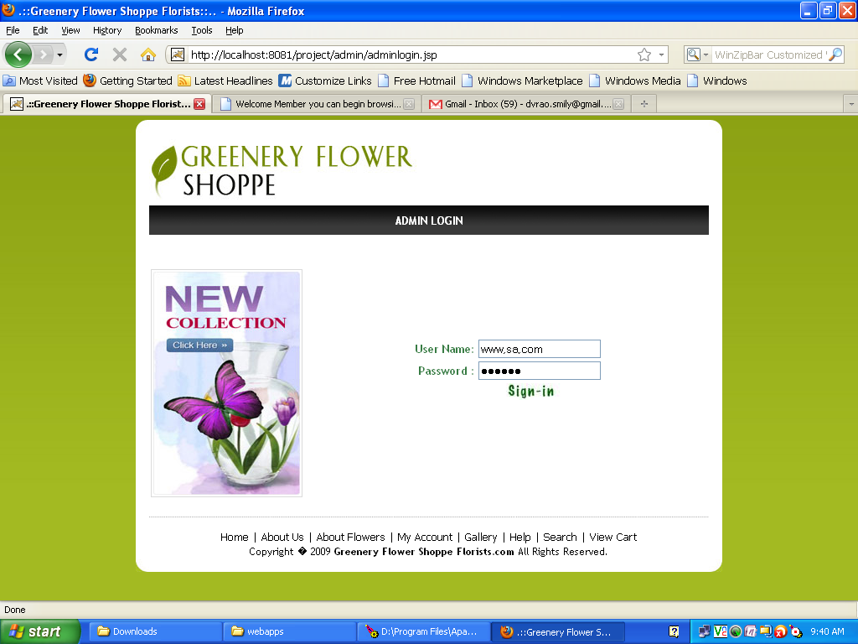

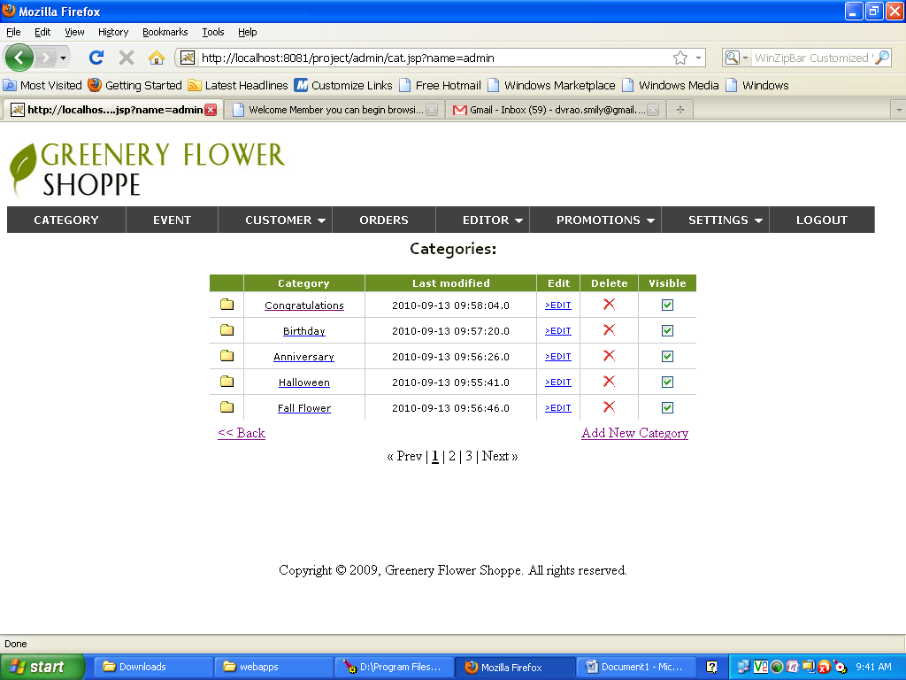

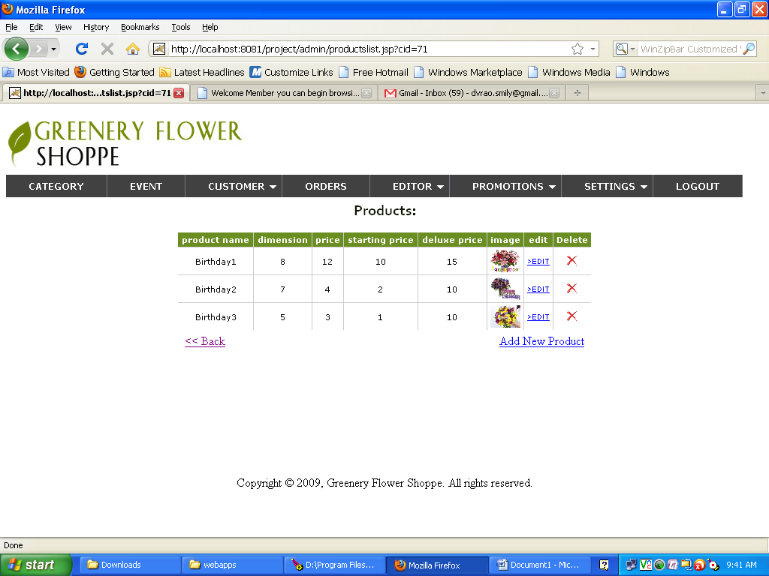

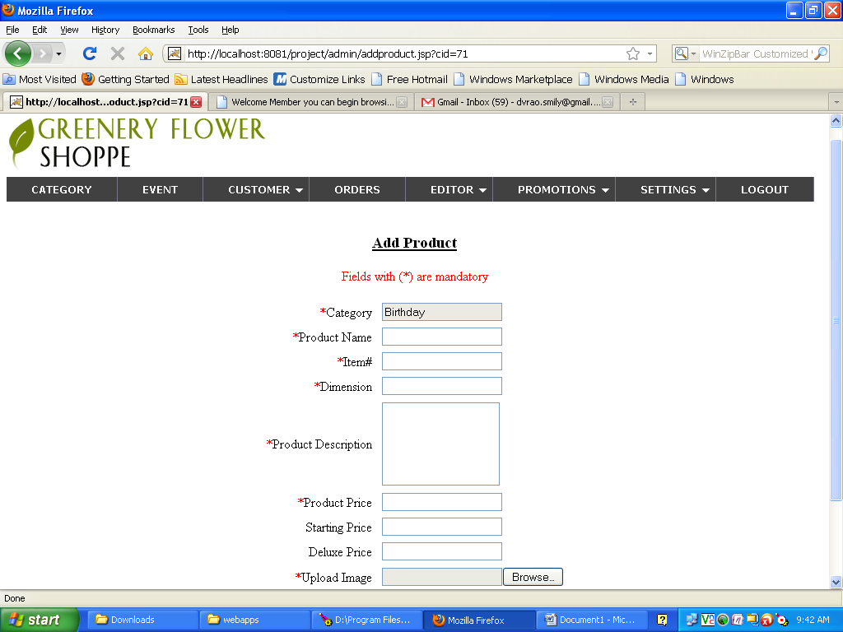

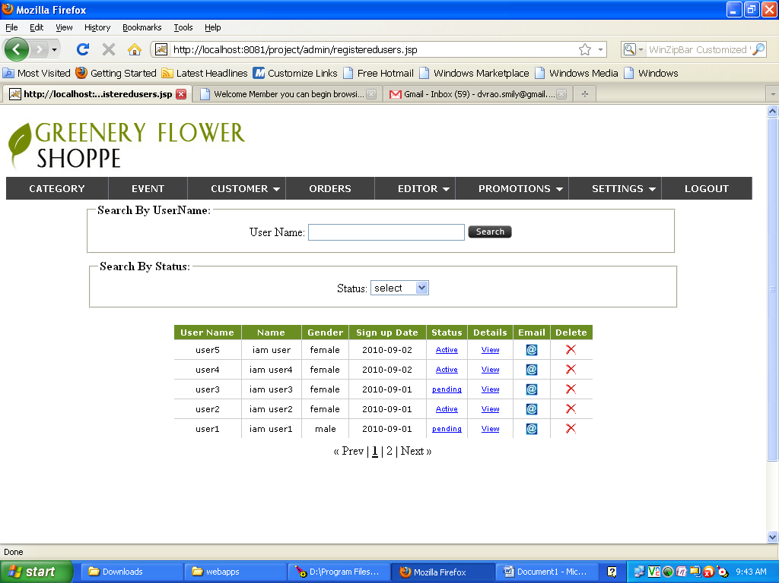

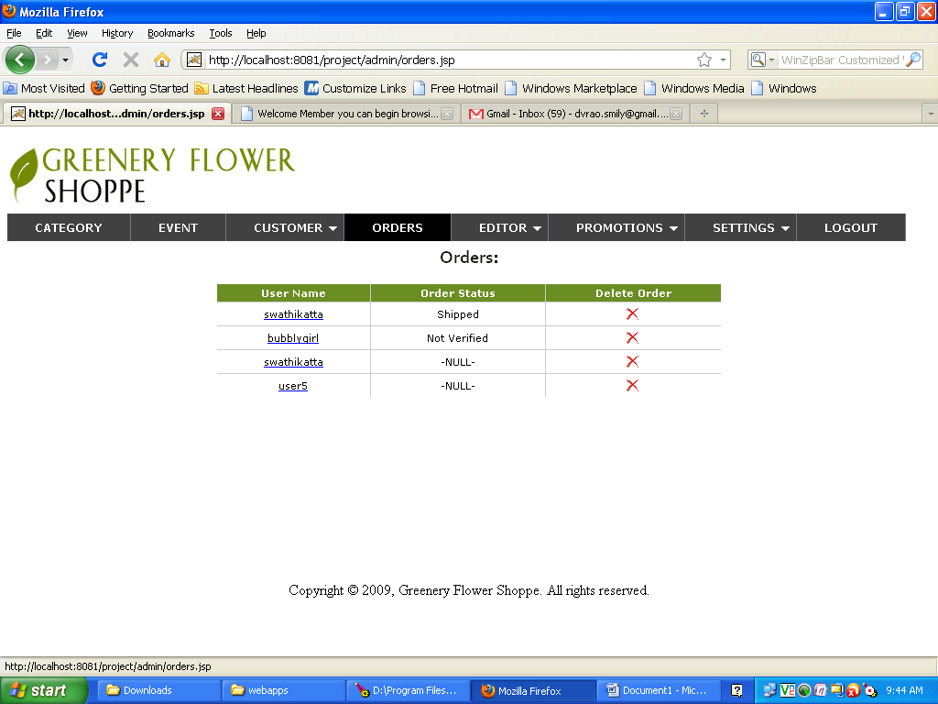

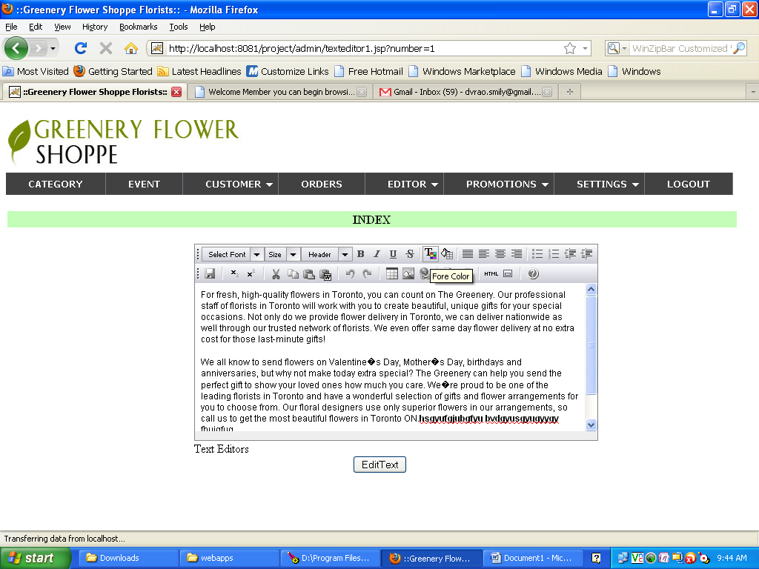

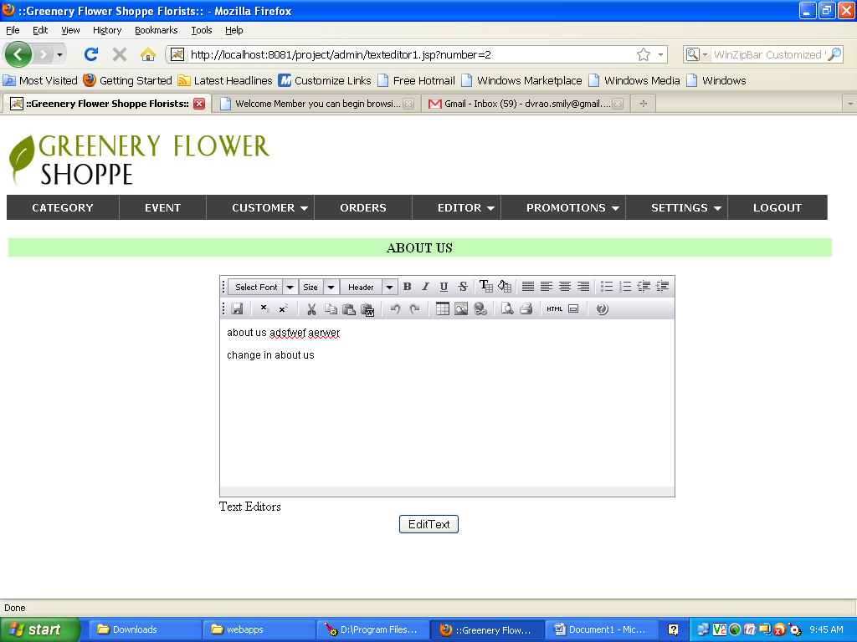

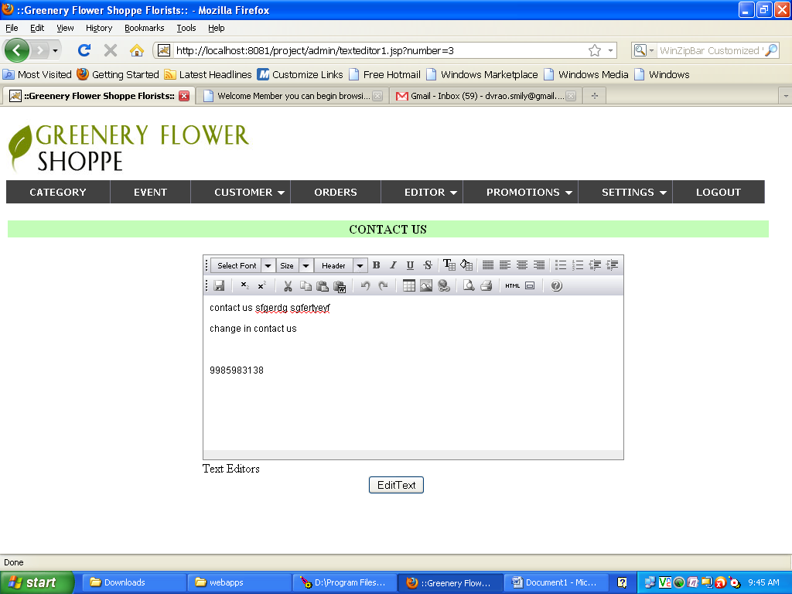

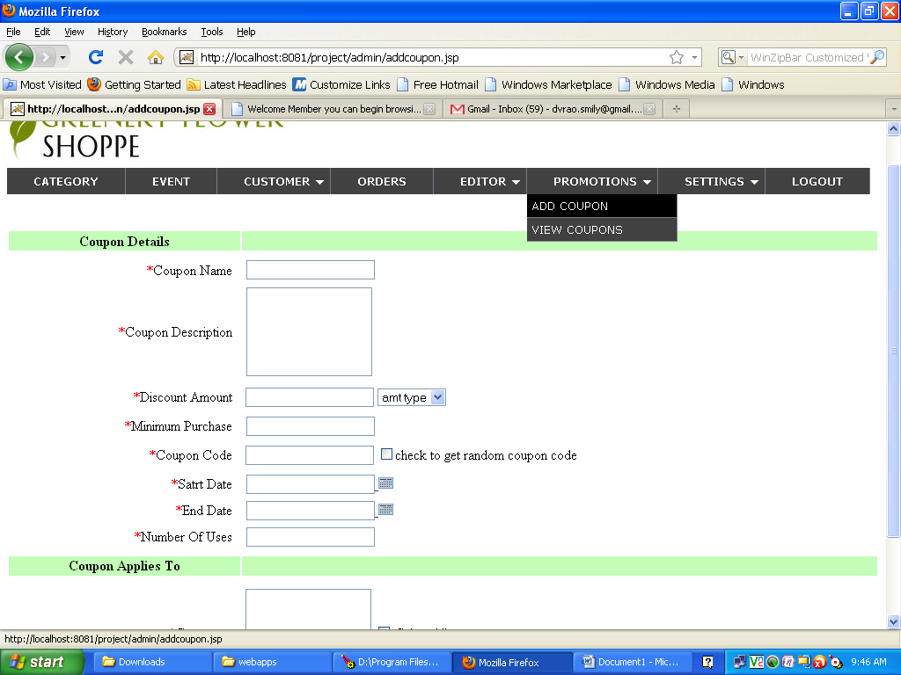

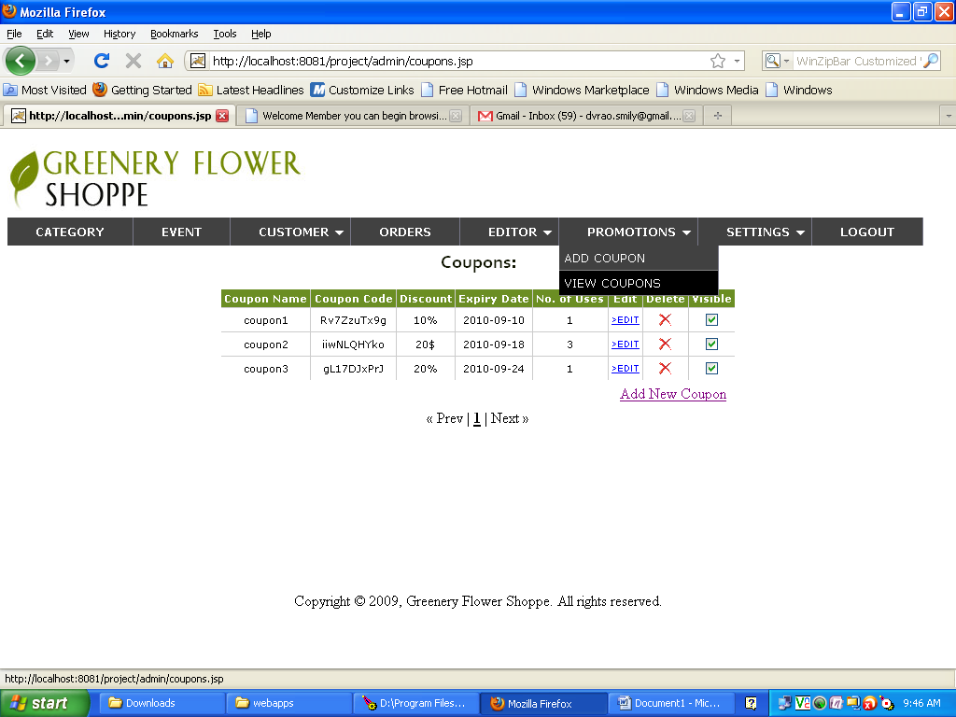

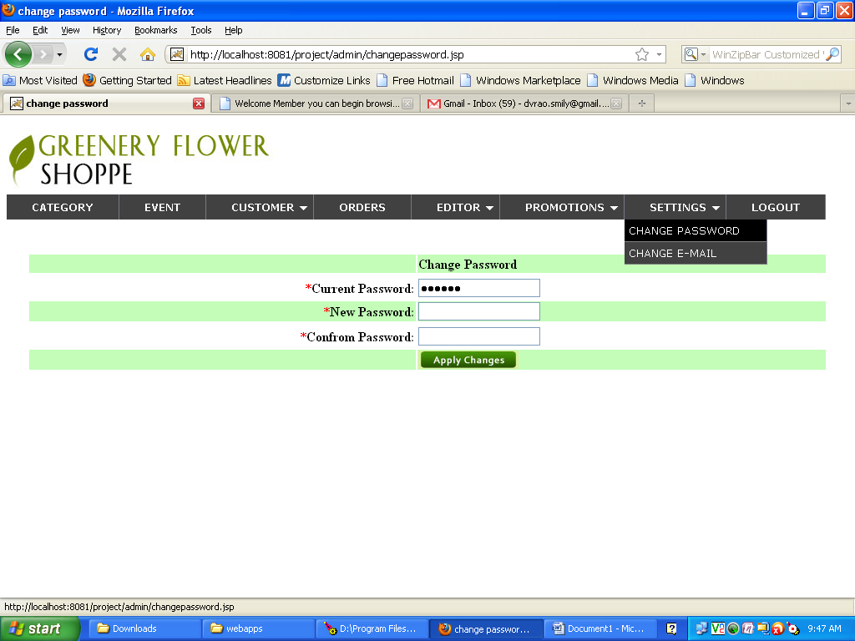

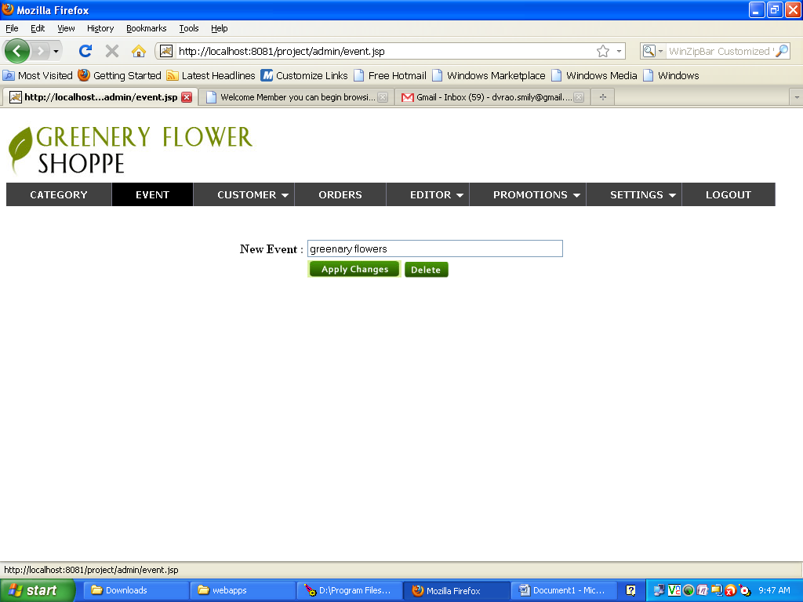

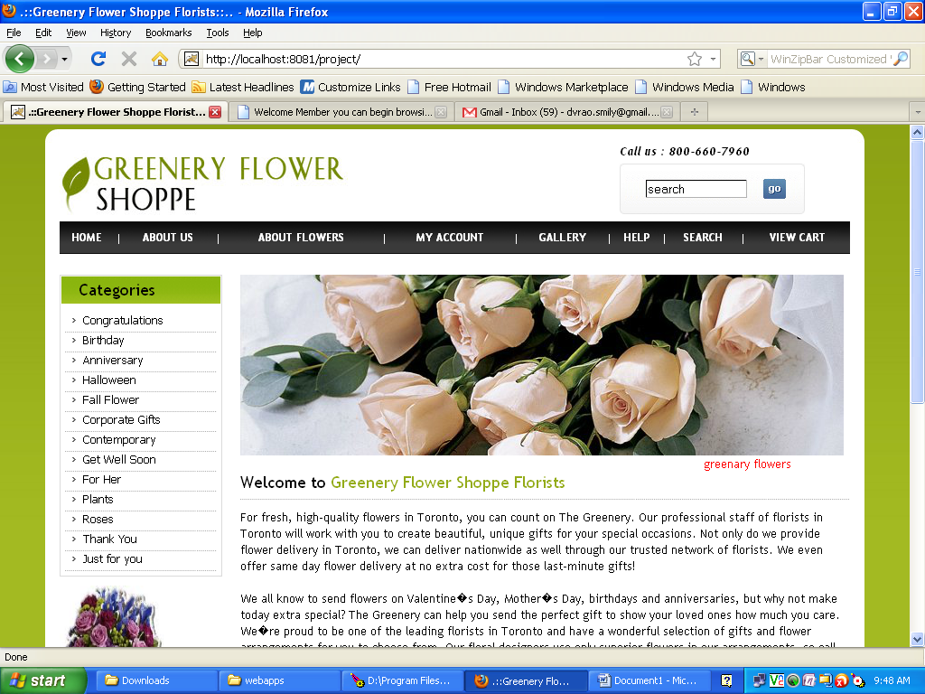

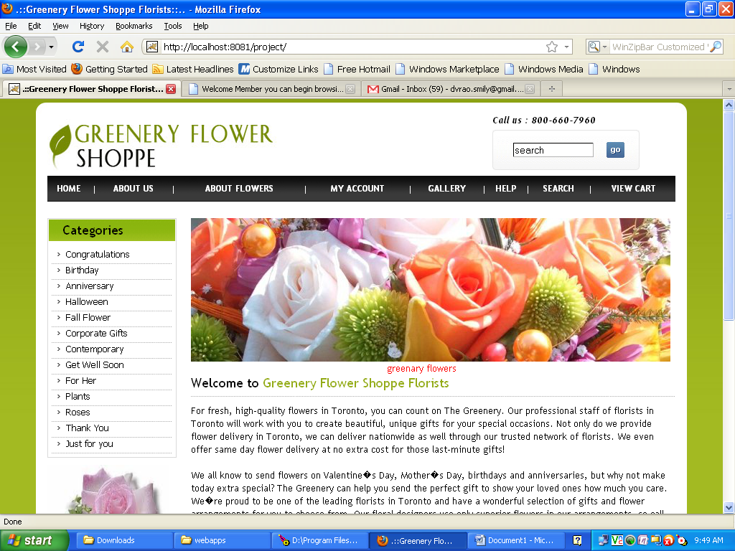

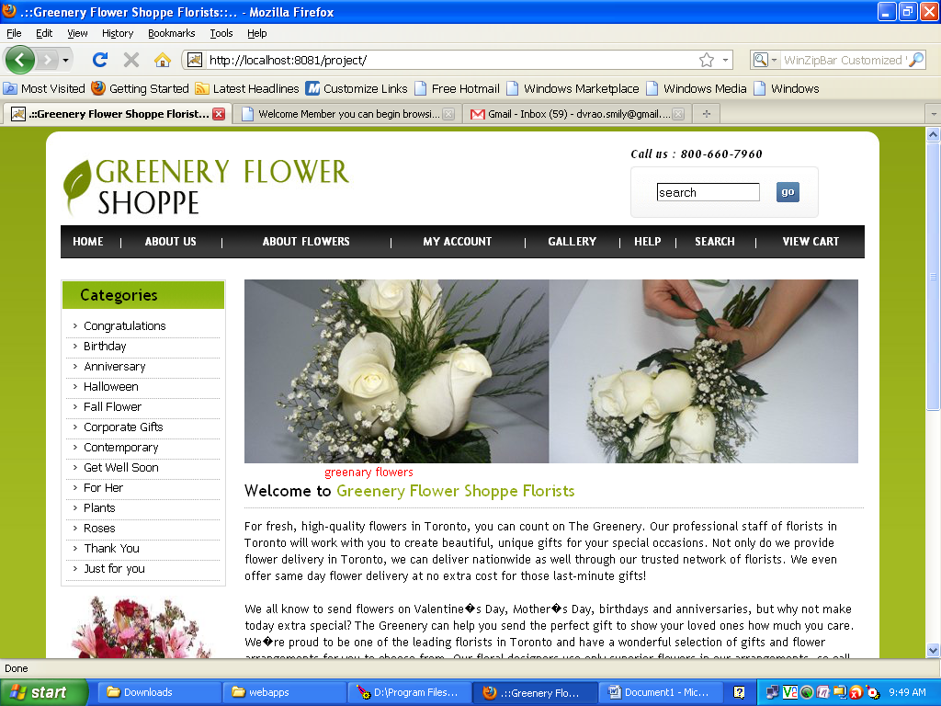

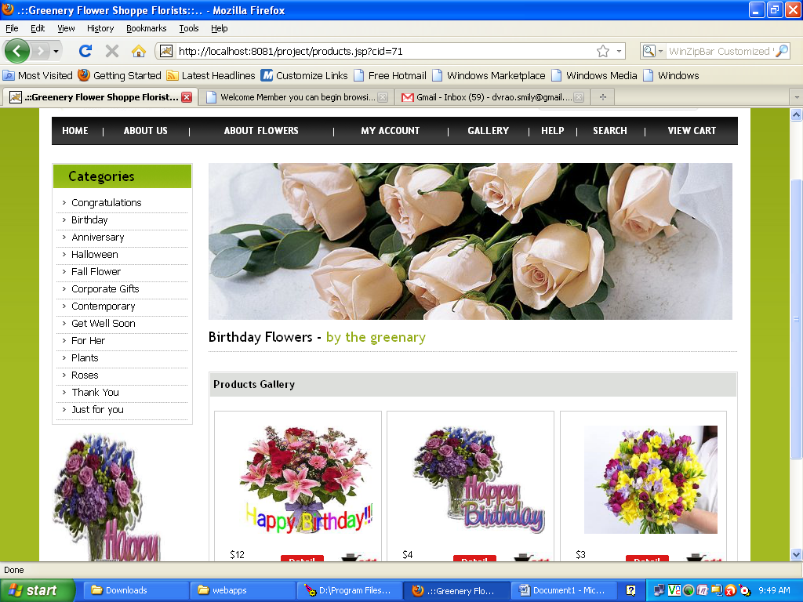

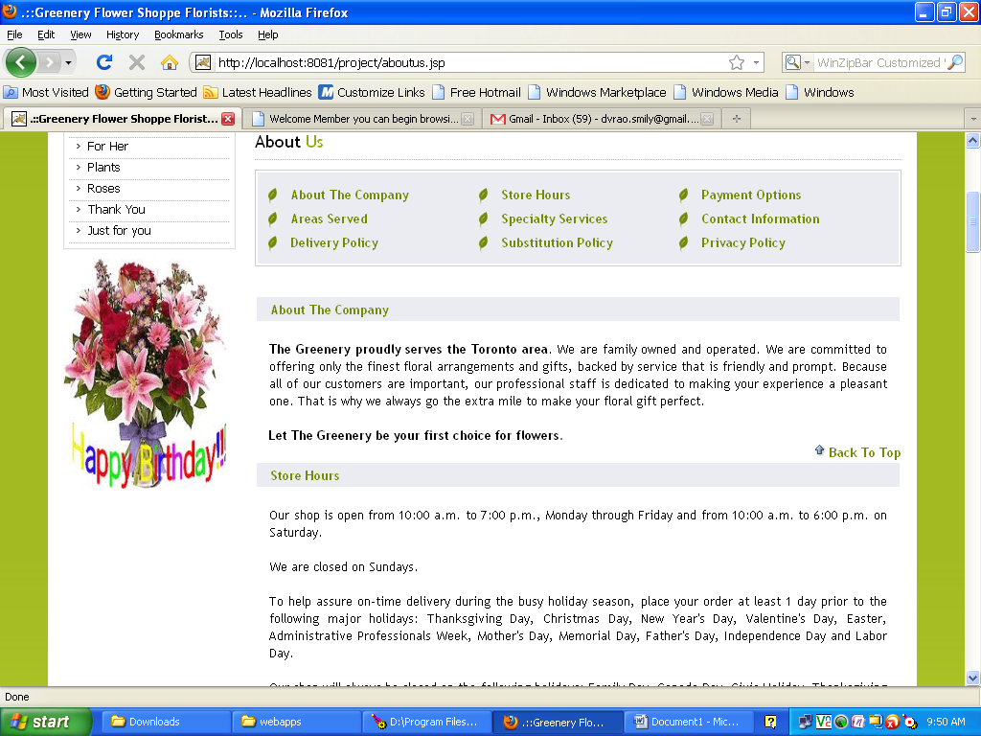

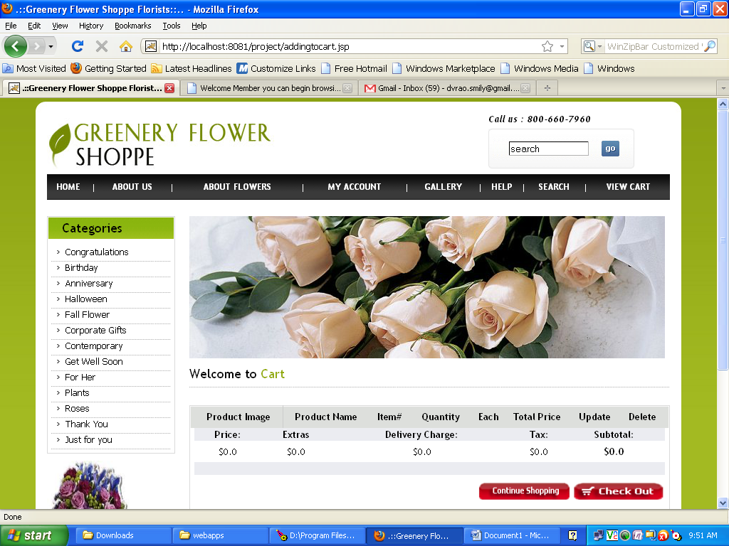

8.TESTING

Levels of Testing

In order to uncover the errors present in different phases we have the concept of levels of testing. The basic levels of testing are as shown below…

Acceptance Testing

System Testing

Integration Testing

Unit Testing

Client Needs

Requirements

Design

Code

System Testing

The philosophy behind testing is to find errors. Test cases are devised with this in mind. A strategy employed for system testing is code testing.

Code Testing:

This strategy examines the logic of the program. To follow this method we developed some test data that resulted in executing every instruction in the program and module i.e. every path is tested. Systems are not designed as entire nor are they tested as single systems. To ensure that the coding is perfect two types of testing is performed or for that matter is performed or that matter is performed or for that matter is performed on all systems.

*Types Of Testing*

* **Unit Testing**
* **Link Testing**

Unit Testing

Unit testing focuses verification effort on the smallest unit of software i.e. the module. Using the detailed design and the process specifications testing is done to uncover errors within the boundary of the module. All modules must be successful in the unit test before the start of the integration testing begins.

In this project each service can be thought of a module. There are so many modules like Login, HWAdmin, MasterAdmin, Normal User, and PManager. Giving different sets of inputs has tested each module. When developing the module as well as finishing the development so that each module works without any error. The inputs are validated when accepting from the user.

In this application developer tests the programs up as system. Software units in a system are the modules and routines that are assembled and integrated to form a specific function. Unit testing is first done on modules, independent of one another to locate errors. This enables to detect errors. Through this errors resulting from interaction between modules initially avoided.

Link Testing

Link testing does not test software but rather the integration of each module in system. The primary concern is the compatibility of each module. The Programmer tests where modules are designed with different parameters, length, type etc.

Integration Testing

After the unit testing we have to perform integration testing. The goal here is to see if modules can be integrated proprerly, the emphasis being on testing interfaces between modules. This testing activity can be considered as testing the design and hence the emphasis on testing module interactions.

In this project integrating all the modules forms the main system. When integrating all the modules I have checked whether the integration effects working of any of the services by giving different combinations of inputs with which the two services run perfectly before Integration.

System Testing

Here the entire software system is tested. The reference document for this process is the requirements document, and the goal os to see if software meets its requirements.

Here entire ‘ATM’ has been tested against requirements of project and it is checked whether all requirements of project have been satisfied or not.

Acceptance Testing

Acceptance Test is performed with realistic data of the client to demonstrate that the software is working satisfactorily. Testing here is focused on external behavior of the system; the internal logic of program is not emphasized.

In this project ‘Network Management Of Database System’ I have collected some data and tested whether project is working correctly or not.

Test cases should be selected so that the largest number of attributes of an equivalence class is exercised at once. The testing phase is an important part of software development. It is the process of finding errors and missing operations and also a complete verification to determine whether the objectives are met and the user requirements are satisfied.

White Box Testing

This is a unit testing method where a unit will be taken at a time and tested thoroughly at a statement level to find the maximum possible errors. I tested step wise every piece of code, taking care that every statement in the code is executed at least once. The white box testing is also called Glass Box Testing.

I have generated a list of test cases, sample data. which is used to check all possible combinations of execution paths through the code at every module level.

Black Box Testing

This testing method considers a module as a single unit and checks the unit at interface and communication with other modules rather getting into details at statement level. Here the module will be treated as a block box that will take some input and generate output. Output for a given set of input combinations are forwarded to other modules.

*Criteria Satisfied by Test Cases*

* + - * 1. Test cases that reduced by a count that is greater than one, the number of additional test cases that much be designed to achieve reasonable testing.
        2. Test cases that tell us something about the presence or absence of classes of errors, rather than an error associated only with the specific test at hand.

USER MANUAL:

Installation

* + - The database as it is developed by Oracle8i can be installed only by using the export and import concepts.
    - Using core java and components like JSP and Java beans needs proper deployment as per general specifications developed the front end as it.

**9.CONCLUSION**

For fresh, high-quality flowers in Toronto, you can count on The Greenery. Our professional staff of florists in Toronto will work with you to create beautiful, unique gifts for your special occasions. Not only do we provide flower delivery in Toronto, we can deliver nationwide as well through our trusted network of florists. We even offer same day flower delivery at no extra cost for those last-minute gifts!

Certain varieties of cut flowers last longer than others. Carnations, for example, can remain vibrant for long periods. Roses have a shorter vase life, but are prized for their special and delicate beauty. When buying flowers, be sure to ask your florist how long you should expect your arrangement to last. Whatever variety you choose, a little TLC will go a long way to keep your blooms looking fresh longer. Here are a few handy tips that can help add days to their beauty!

Floral food is a combination of additives that help to nourish the flowers and discourage bacteria from growing in the water. It is one of the best�and easiest�ways to extend the life of your flowers. It is very important to follow the directions on the package correctly. Improperly mixed floral food can do more harm than good.

It is easy process to send any person from anywhere.

**11. Bibliography**

References for the Project Development were taken from the following Books and Web Sites.

**Oracle**

PL/SQL Programming by Scott Urman

SQL complete reference by Livion

**JAVA Technologies**

JAVA Complete Reference

Java Script Programming by Yehuda Shiran

Mastering JAVA Security

JAVA2 Networking by Pistoria

JAVA Security by Scotl oaks

Head First EJB Sierra Bates

J2EE Professional by Shadab siddiqui

JAVA server pages by Larne Pekowsley

JAVA Server pages by Nick Todd

**HTML:** HTML Black Book by Holzner

**JDBC**

Java Database Programming with JDBC by Patel moss.

Software Engineering by Roger Pressman